**MY TEACHING PHILOSOPHY STATEMENT**

**H. (CLOUD) HENG**

*“If you educate one person, you can change a life; if you educate many people, you can change the world”- Nas Daily*

**A young man who experienced life changing under the power of education**

This is a story about a young man who was struggling in his early stage of middle school. His grade was constantly dropping and he was not confident in his ability to be successful in technical courses like science and maths. Fortunately, in his high school life, this young man met a few marvelous science and math educators who were passionate about teaching and made extra effort for students’ development. Therefore, the passion of this young man in learning science and math grew exponentially, which further drove him to pursue education in Mechanical Engineering. If someone were to ask me, is that possible to transform a student from a miry clay into a shiny star? Without hesitation, I would definitely answer “yes” because this young man is me! From a student who was greatly lacking confidence in algebra and physics, I have been turned into an exceptional engineering student who has been awarded the Best Mechanical Engineering Graduate, on account of the power of education and dedicated teachers! This story of mine has allowed me to realize that teachers are like a candle who consumes itself to light the way for others, as stated by Mustafa Kemal Ataturk. I strongly believe in the impact of education in changing people’s lives, and I constantly strive to be a candle who will light up and transform more people through the power of education, just like how I was transformed. Therefore, I am writing this teaching philosophy statement to illustrate:

* my personal value and goal in teaching,
* my teaching strategies, and
* my commitment for continuous improvement in teaching.

**My personal value and goal in teaching**

Teaching is not just a profession, it is a passion! I am passionate to educate young people because I believe they are the strongest asset in any organizations. Although sometimes youth is considered as the least experience group, I believe they can view things from different angles, introduce fresh ideas, and contribute significantly with their creativity. The passionate attitude of engineering educators is an essential element to allow young students to be aware of the social impact of engineering study, and establish their confidence in applying engineering knowledge in society. Although engineering is a complicated study that is sometimes not enjoyable by many people, I believe students’ interest can be built progressively through the passion of educators. Hence, my general teaching goal is to cultivate interest in learning engineering among my students by allowing them to witness my teaching passion in engineering. To demonstrate my teaching passion, I put a strong emphasis in classroom engagement, which includes designing more participatory learning activities, encouraging questions, and listening to ideas openly. From my GPS 989 microteaching written evaluation, 75% of the respondents commented that my teaching passion can be clearly observed, and my teaching was very interactive. This result is strong evidence that teaching passion leads to engaging lectures that would be appreciated by students.

**My teaching strategies**

Teaching method varies across different educators, and I believe the method used impacts students’ development in engineering subjects. For instance, a teaching approach with pure direct instruction might not favor students who enjoy learning by doing. Similarly, a teaching strategy that involves only spoken instruction without any written content might only favor auditory learners. As engineering courses are complex, it is not surprising students’ dropout rate in engineering program is evident every year after students are no longer finding the courses are enjoyable. This consequence might be due to most of the teaching approach used does not match with their learning preferences. Therefore, understanding that students are coming from different backgrounds with different learning preferences, I remind myself that it is necessary to adopt teaching methods that are able to accommodate various learning preferences. During the introduction of theories related to an engineering concept, I use well-balanced spoken and written instructions for the benefit of both visual and auditory learners. I also like to discuss a few problem solving examples that are related to the theories taught, which is an approach that practical learners enjoy the most. For laboratory courses, practical learners can be accommodated through my lab demonstration on the relevant equipment with experiential instructions. I also realize that engineering theories are closely related to daily life applications, so teaching engineering is an excellent platform to show the relevancy of contents taught in our daily life. Therefore, I also adopt my apprenticeship teaching perspective by giving additional case studies or daily life applications that closely relate to the contents taught to allow them to visualize how the contents taught are relevant. I often use interactive instruction when discussing case studies to enhance two- or three- ways communication between teacher-student and student-student. My teaching strategy consists of a balanced mixture of different instruction approaches and is generally friendly to different adult learners. I have adopted this strategy in my first lab demonstration assignment, and it is evident that this strategy is effective from the students’ feedback as shown in Appendix A.

**My commitment for continuous improvement in teaching**

Teaching is a continuous process and hence I am committed to continuous improvement process in my teaching. I see evaluation as a key element to measure my teaching effectiveness and my students’ learning success, so I strongly encourage my students to participate in the evaluation process to support my continuous improvement goal. Some students’ feedback in my second lab demonstration assignment is shown in Appendix B. I also insist the necessity of teaching reflection. For instance, I used to be an educator who focused solely on grading students and differentiating their performances. However, after reflecting on my strategy in assessing students, I realized that the assessment should be part of students’ learning process, instead of just measuring and reporting students’ performances. Hence, I have adopted more formative assessments that focus more on providing constructive feedback to students. Additionally, I am regularly enrolling in courses that support my lifelong learning goal and enhance my credibility as a teacher, so that I have the opportunity to learn from instructors and peers about effective communication and strategies for successful learning. Some examples of the courses taken include Philosophy and Practice of University Teaching (Appendix C), and Advanced Spoken English (Appendix D).

**Does my teaching philosophy matter?**

My teaching philosophy serves to retain my motivation in educating people about engineering. On account of my passion, I was given an opportunity by my supervisor in my master’s program to deliver a lecture of Fluid Mechanics for about 80 students. It was a vivid memory for me when my supervisor introduced me in front of the class before my lecture began. I adopted the same philosophy written above in this first lecture of mine and hoped that it would work. Surprisingly, an unexpected round of applause was given right after I finished my last sentence in the lecture without being requested by neither my supervisor nor me. That applause has further confirmed my beliefs in teaching and helped me further realize my strong potential in teaching engineering. My life would be so meaningful if I could continue being a candle who utilizes education to light up hope for more people who are hungry for knowledge. I might be surprised one day when my students who receive my teaching continue to spread the light (knowledge) to others and contribute something meaningful to their societies and countries, and then transform the world to a better place to live, under the shadow of education.

# Appendix A: Students’ Feedback in ME 318, F2 (Wind Turbine Lab – Fall 2018)

* The TA was extremely clear in explanations and very helpful.
* The TA was great and the explanations were very clear but the instrumentation on the turbine was broken so the data was impossible to analyze.
* Cloud was the best lab TA I have ever had.

*Anonymous*

# Appendix B: Students’ Feedback in ME 318, F3 (Boundary Layer Measurement Lab – Winter 2019)

* Lab is organized and well out together.
* Cloud is very passionate about teaching and gives excellent feedback.
* Cloud is very nice and taught clearly during lab. He is the best TA in this term!
* Cloud is an awesome TA who puts a lot of effort into ensuring a good learning experience, and also provides a lot of valuable feedback on log-books, beyond what is just in the rubric
* Cloud is one of the best TA’s, makes sure everyone understands and is on board before moving on. The wind tunnel was interesting but there should be an added aspect to the lab while we wait for out turn because sitting for almost an hour doing nothing felt like a waste of time.
* I highly recommend to give a reward to Cloud because he really put a lot of effort to do the job, he commented almost every mistakes that I made and gave the correct answer which made me understand the lab better.

*Anonymous*

**(Reference: Prof. David Sumner; david.sumner@usask.ca)**

# Appendix C: Certificate of GPS 989 (Philosophy and Practice of University Teaching)

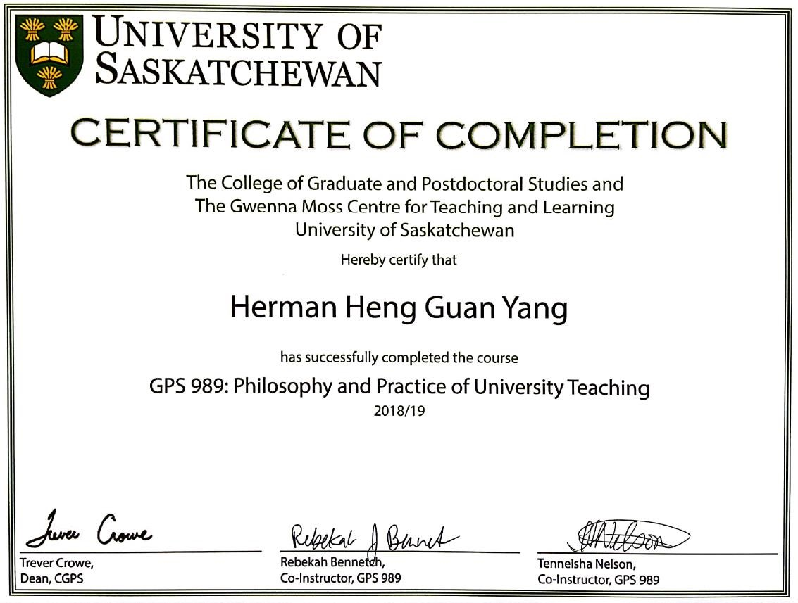

# Appendix D: Certificate of Advanced Spoken English

